Action Plan Guidance Notes
The Action Plan can be applied as a simplified Farm Business Resilience Plan to capture what growers would like to achieve in their business. For each management area, their goals, planned activities, analysis of associated risks and expected outcomes. Note the plan date and review date.

Motivation
Summarise what you wish to achieve with your business, what you expect the plan to achieve for your business.

Management Areas
For each management area, document the below:

Goal
(S.M.A.R.T = Specific, Measurable, Achievable, Realistic, Timeframe)
Aim to write your goal using the below principles
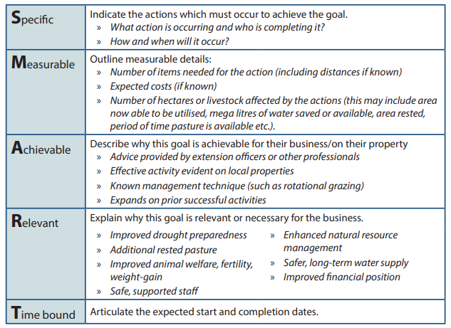

Action
(who does it? How much? Of what? By when?)
Be specific, identify who is responsible, include quantifiable details. Eg: megalitres, hectares applied, type of improvement, method etc. Include what is planned to be actioned and time frame.

Outcome
(document quantifiable difference; e.g., extra land, megalitres, yield)
Document what difference you expect the proposed actions will make. What are you hoping to achieve. Again, include quantifiable information such as megalitres, hectares, time, dollars etc.

Risk Analysis
For each management area: Dot point the main risks faced by your business and the strategies used to manage or mitigate them. Consider risks when designing actions for each management area, as risk mitigation will impact outcome achieved.

Indicate a risk level | Likelihood | Consequence | Impact
Use the likelihood consequence risk matrix table to determine likelihood and consequence | Insert drop down list per risk matrix box | Insert drop down list per risk matrix box | Auto insert impact and colour as per risk matrix box

How to use the likelihood consequence risk matrix.

- Determine how likely is the event to occur (likelihood)
- Determine the severity (consequence) of damages / financial impacts if the risk event actually occurred
Example:
If the likelihood for the activity is determined as “unlikely” and the consequence for the activity is determined as “moderate”.
Then likelihood and consequence intersect at “low medium”. Therefore, the activity has an associated low to medium risk.
Risk level:
Low | Minimal risk: No specific management action required.
Low Med | Acceptable risk: Monitor management actions
Medium | Acceptable risk: Specific management / monitoring needed.
High | Not acceptable risk: Increase in management actions needed, monitor and review.
Severe | Unacceptable.

Likelihood Consequence Risk Matrix
 | Consequence
Likelihood |  | Insignificant | Minor | Moderate | Major | Critical
 | Almost Certain | Low Med | Medium | High | Severe | Severe
 | Likely | Low Med | Medium | Medium | High | Severe
 | Possible | Low | Low Med | Medium | High | Severe
 | Unlikely | Low | Low | Low Med | Medium | High
 | Rare | Low | Low | Low | Low Med | Medium

